Pyge

Outcome 3: Testing Documentation

Introduction
This document provides evidence that there are not discrepancies in the test results, that the program is error free and that the program satisfies the brief/specification.

Tests
Where tests provide intelligible output screenshots are added. Screenshots of, for example, exiting the program for test 5 are not included as there is nothing to show.
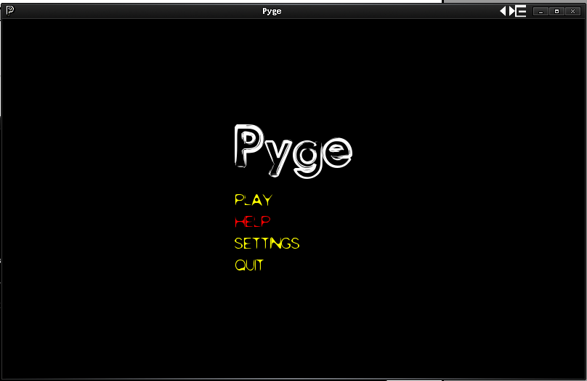
Test 0
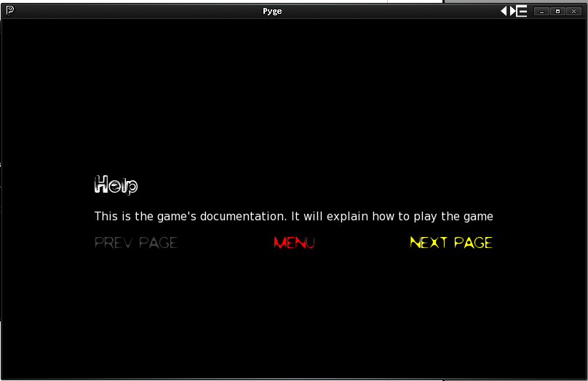
Test 1, 2, 3
Test 4
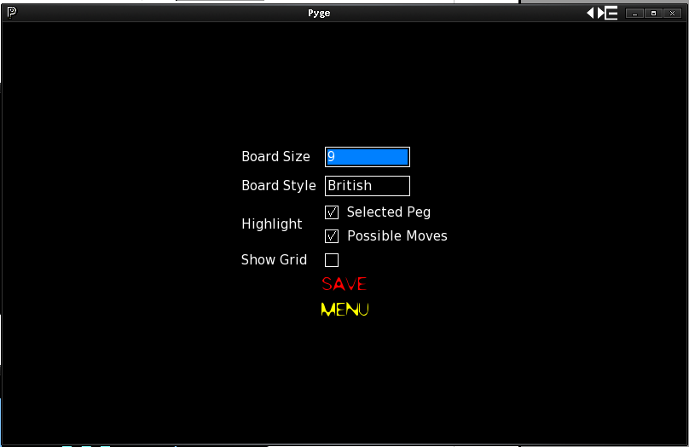

Settings File:
{"highlight_moves": true, "board_style": "British", "board_size": 9, "highlight_selected": true, "show_grid": false}
Test 6, 7
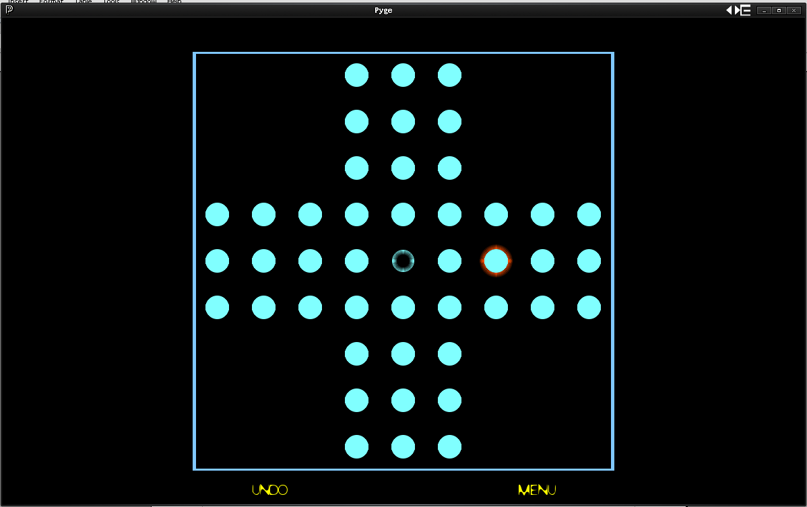
Settings File:
{"highlight_moves": true, "board_style": "British", "board_size": 9, "highlight_selected": true, "show_grid": false}
Test 8
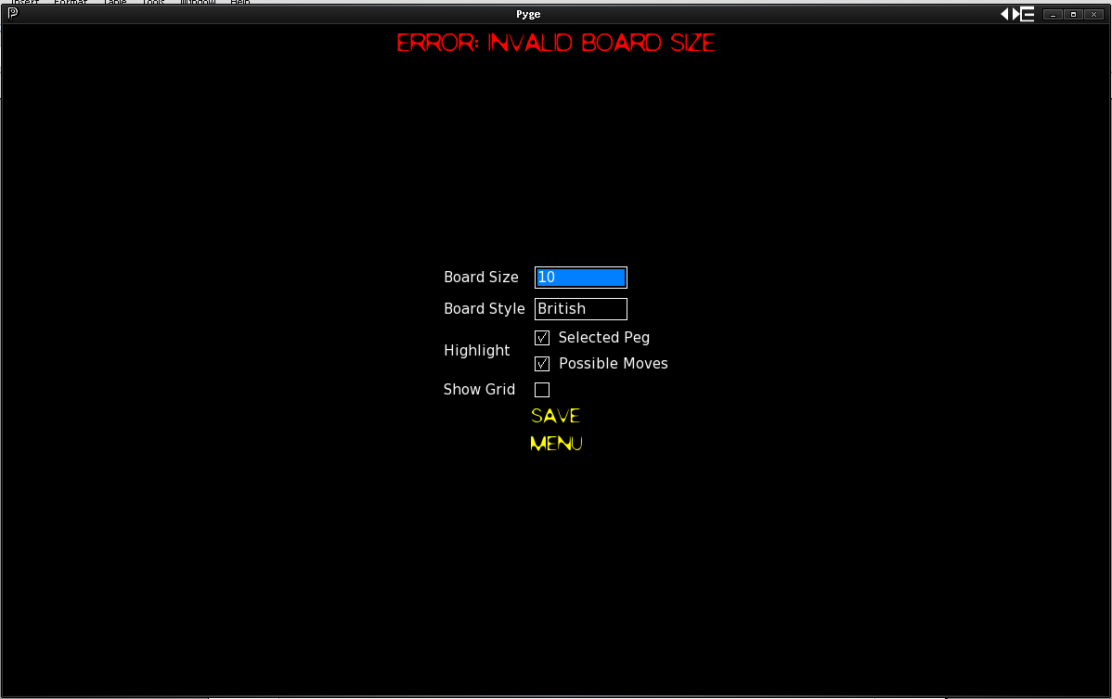
Test 10
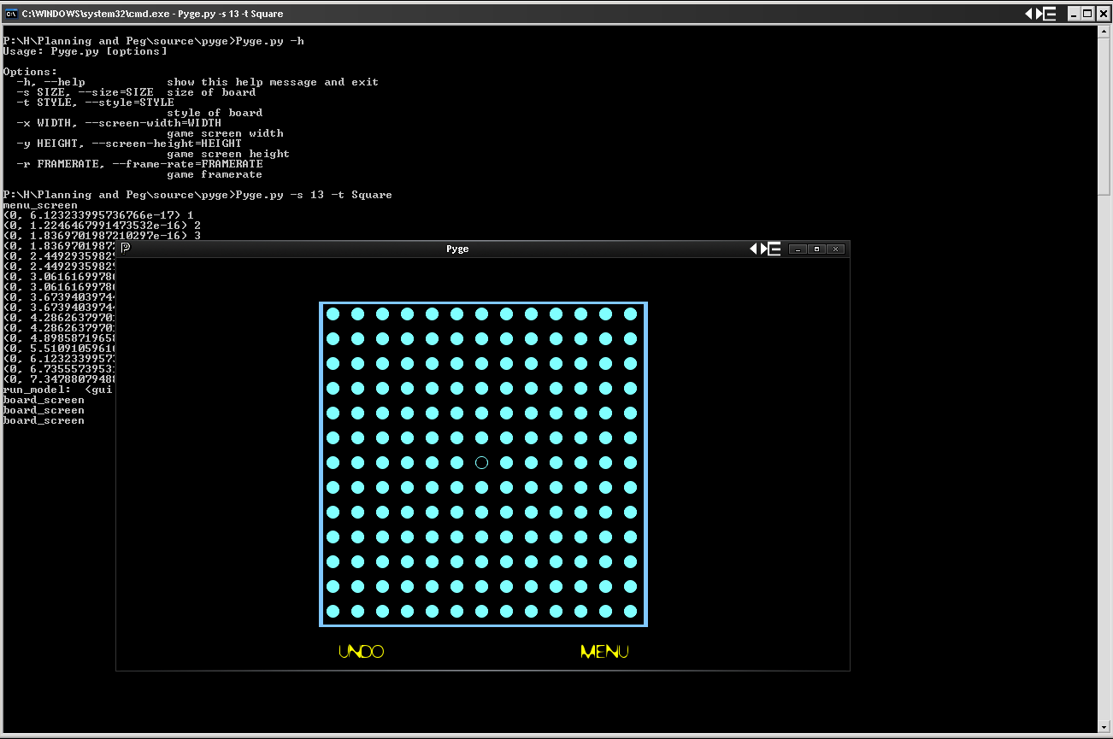
Test 9
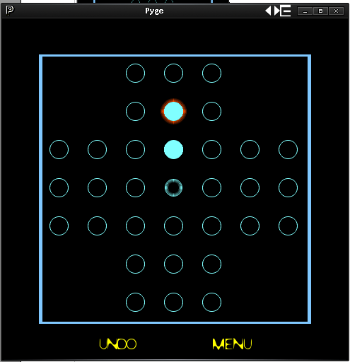
Move 0
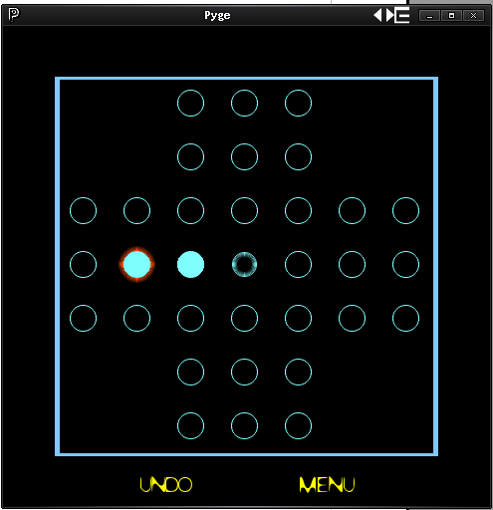
Move 1
Move 2
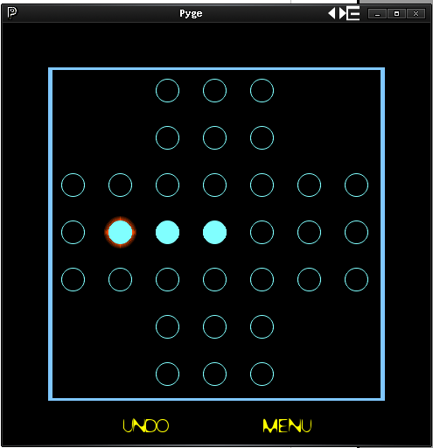
Move 3
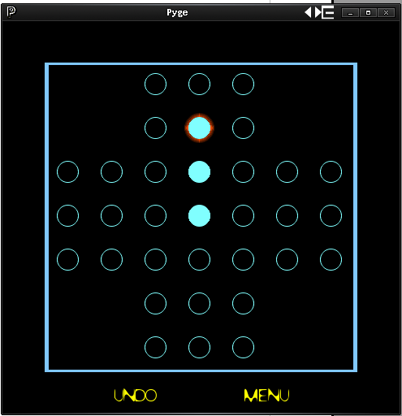
Move 4
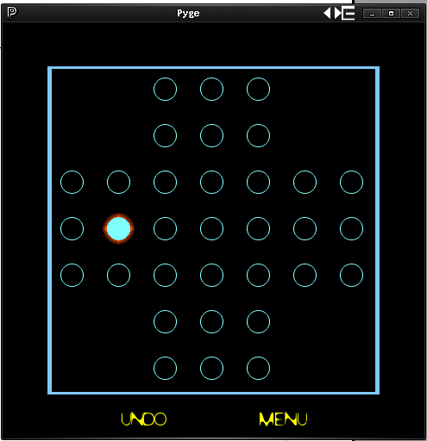
Moves 5 to 13
The developers screenshot button broke and so further screenshots of the Game Rules Test Cases are sadly unavailable at this time.

